BIT3208
Advanced Web Design and Development

PRACTICAL LOGBOOK
AuraMart E-Commerce Web Application
Name | HUBERT.M,MULAMA
Admission Number | BBIT/2024/56387
Course / Class | BBIT
Unit Code | BIT3208
Unit Name | Advanced Web Design and Development
Lecturer Name | MR.NYORO MICHAEL
Semester / Year | 3.2

Project Title | AuraMart E-Commerce Web Application
Technologies | PHP + MySQL, HTML5, CSS3, JavaScript, XAMPP
GitHub / Portfolio

Academic Year 2026

Table of Contents
(Auto-generate in Microsoft Word: References → Table of Contents)
1 Week 1: Local Environment Setup ............ 3
1.1 Installation Evidence ............ 3
1.2 Student Reflection ............ 4
2 Week 2: Wireframes and GUI Design ............ 5
2.1 Design Evidence ............ 5
2.2 Student Reflection ............ 6

WEEK 1
Local Environment Setup
Installation and Testing of Local Development Environment

Objective
Prepare a professional local web development environment to host and run the AuraMart e-commerce project on a local machine before deployment.

Evidence
The following screenshots document the successful installation and configuration of the local development environment for the AuraMart project.

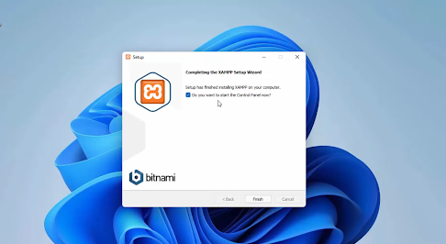
Fig 1: Installation of XAMPP showing successful setup wizard completion on Windows.
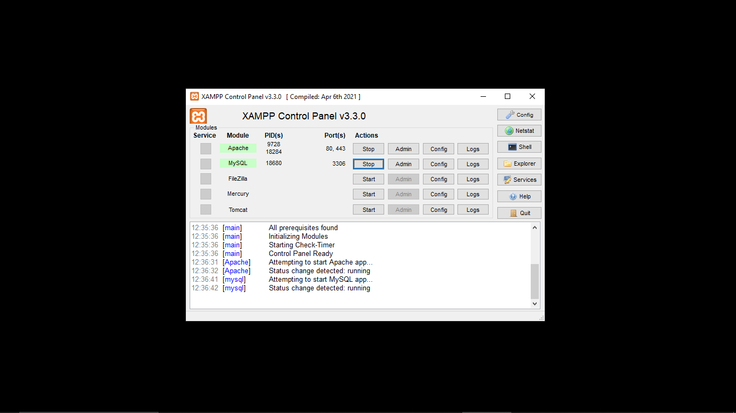
Fig 2: XAMPP Control Panel showing Apache and MySQL services running (green status indicators).
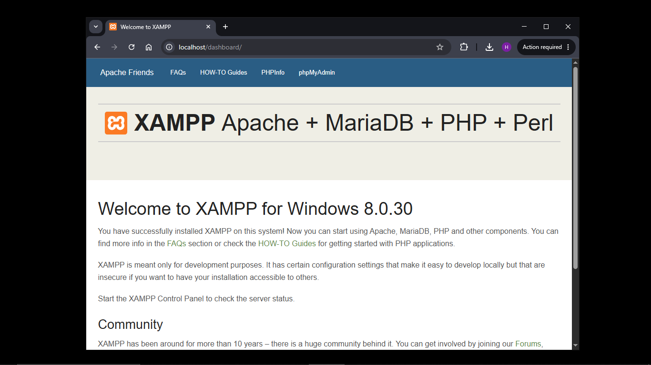
Fig 3: Browser displaying the XAMPP localhost welcome page at http://localhost confirming Apache is active.
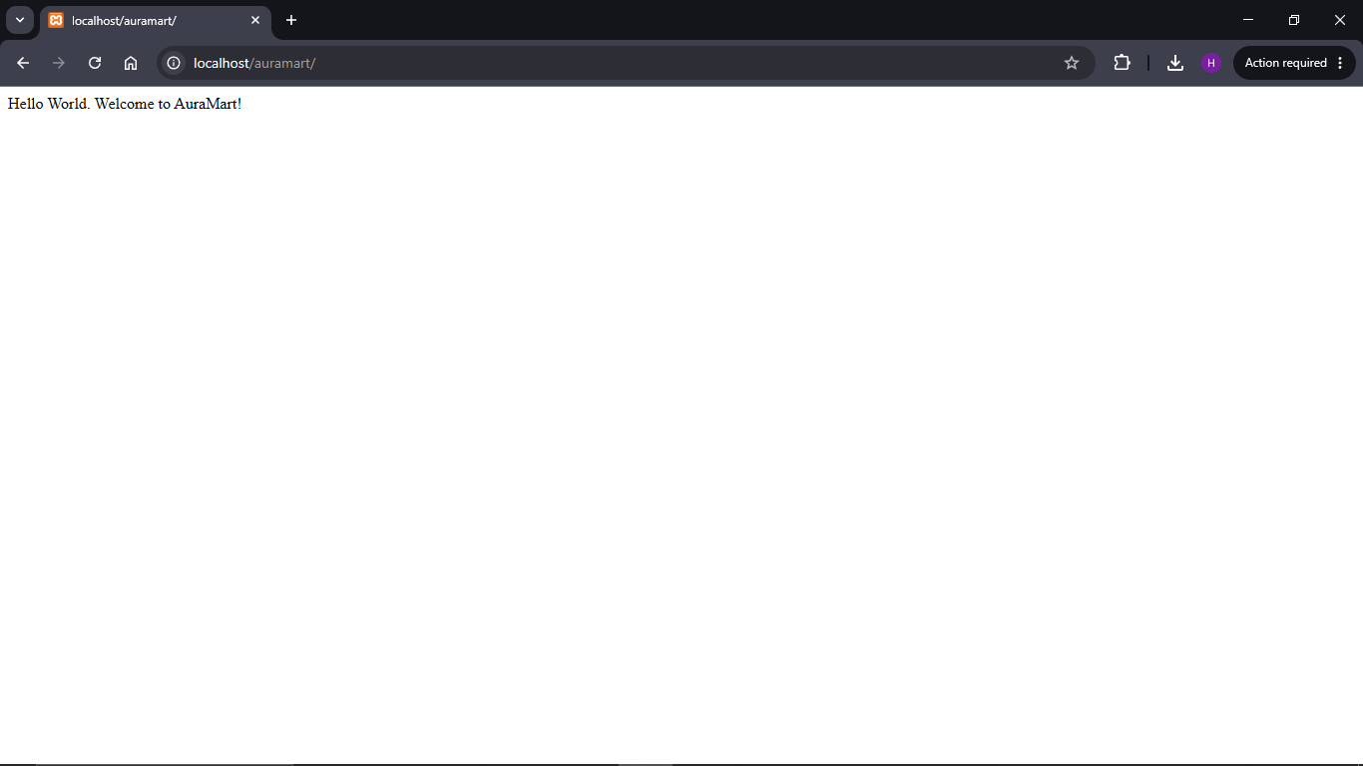
Fig 4: Browser showing the AuraMart Hello World test page at http://localhost/auramart confirming the project folder is correctly configured.
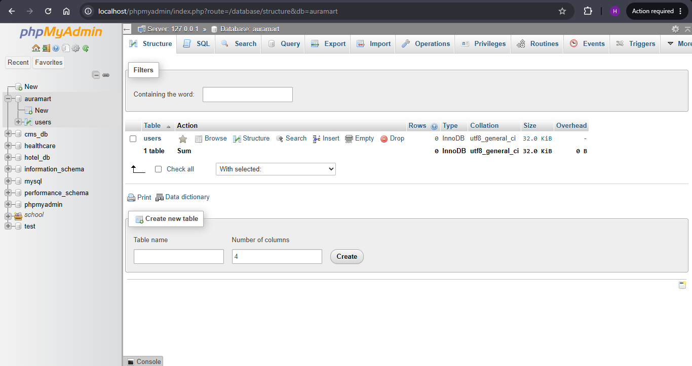
Insert actual screenshot here
Fig 5: phpMyAdmin showing successful connection to MySQL and the creation of the 'auramart' database.

Tools & Technologies Used
Tool | Purpose
XAMPP | Local development server (Apache + MySQL + PHP)
Apache | Web server to serve PHP files locally
MySQL | Relational database management system
phpMyAdmin | GUI tool for managing the MySQL database
VS Code | Code editor for writing HTML, CSS, PHP, and JavaScript
Browser | Google Chrome for testing pages

Deliverables Checklist
- ✅ XAMPP successfully installed and running
- ✅ Apache and MySQL services active on the XAMPP Control Panel
- ✅ Localhost tested and confirmed at http://localhost
- ✅ AuraMart project folder created at C:\xampp\htdocs\auramart
- ✅ Hello World PHP test page created and displayed in browser
- ✅ MySQL database 'auramart' created via phpMyAdmin
- ✅ Database connection test confirmed via PHP (db.php)
- ✅ Screenshots captured and documented in logbook

Student Reflection
Student Reflection
This week I installed XAMPP as my local development environment, enabling Apache and MySQL services to host the AuraMart project locally. Fig 2 confirms both services were running correctly in the XAMPP Control Panel. I created the project folder structure under htdocs and tested a PHP Hello World page. Fig 5 shows a successful database connection using mysqli_connect() in PHP, confirming that the Apache and MySQL configuration was correctly set up. A key challenge was understanding the folder structure and ensuring the connection string matched the database name.

WEEK 2
Wireframes and GUI Design
User Interface Planning and System Design

Objective
Plan and design the complete user interface of the AuraMart e-commerce platform before writing any backend code, ensuring a clear, user-friendly, and responsive design is established.

Project Theme
Project Type | E-Commerce Platform
Project Name | AuraMart
Target Users | Online shoppers (customers) and store administrators
Core Pages | Homepage, Product Catalog, Login, Register, Cart, Checkout, Dashboard, Admin Panel
Design Tools | Figma / Draw.io / Hand-drawn wireframes
Color Theme | Purple (#6C3FC5) on White — modern, clean, professional

Evidence
The following wireframes and GUI mockups document the planned layout and design of the AuraMart application.

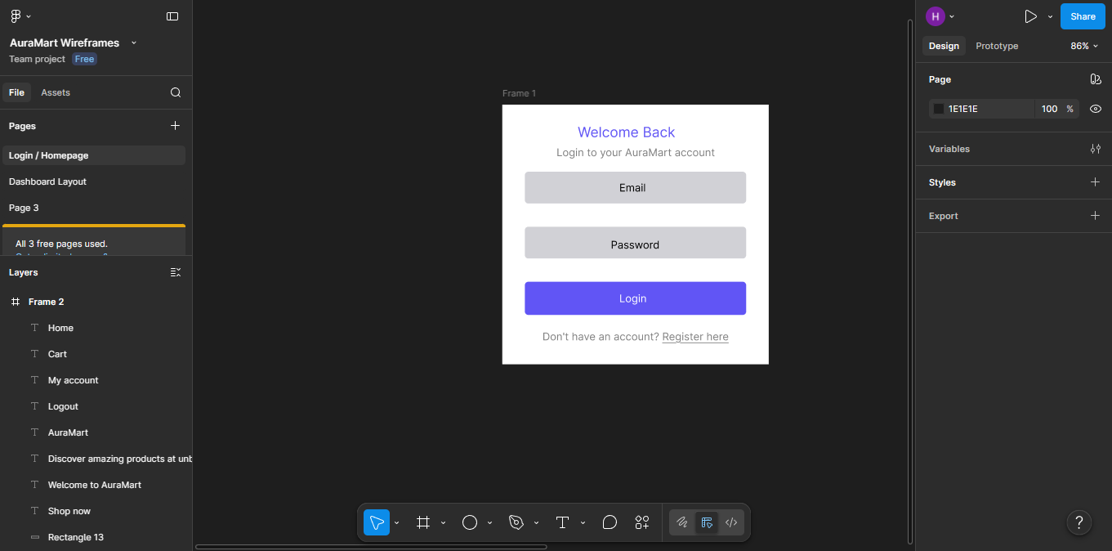
Fig 1: Log in page figma
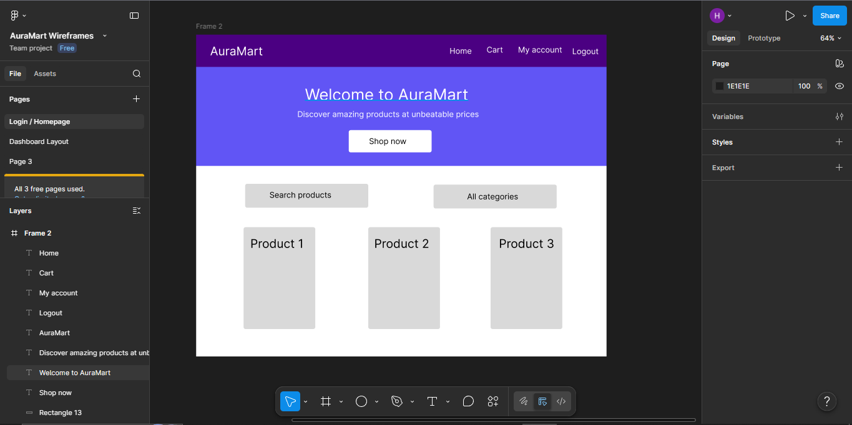
Fig 2: Dashboard layout design
[ Screenshot Placeholder ]
Insert actual screenshot here
Fig 3: Mobile view mockup
[ Screenshot Placeholder ]
Insert actual screenshot here
Fig 4: Color theme and navigation structure
[ Screenshot Placeholder ]
Insert actual screenshot here
Fig 5: GUI prototype in figma

Navigation Flow
The AuraMart system was designed with the following user navigation flow:

Guest User | Customer | Admin
Browse Products | Browse Products | Manage Products
Add to Cart | Add to Cart | Manage Orders
Register / Login | Checkout & Order | Manage Users
 | View Order History | View Revenue Stats

Design Decisions
Color Scheme: Purple (#6C3FC5) was selected to convey trust, creativity, and modernity — aligning with AuraMart's brand identity as a premium online store.
Typography: Segoe UI (sans-serif) was chosen for its clean readability across all screen sizes.
Navigation: A sticky top navbar ensures users can always access the cart and account pages regardless of scroll position.
Product Grid: CSS Grid with auto-fill columns allows the product catalog to automatically reflow across desktop, tablet, and mobile screens.
Role-Based UI: The interface adapts based on user role — customers see their dashboard and orders; admins see the full management panel.
Mobile Responsiveness: All layouts use flexible grids and media queries to ensure usability on screens as small as 375px.

Deliverables Checklist
- ✅ Homepage wireframe designed (navbar, hero, product grid, footer)
- ✅ Login and Registration page wireframes completed
- ✅ Customer Dashboard layout designed
- ✅ Admin Panel layout designed with sidebar navigation
- ✅ Mobile responsiveness mockup created
- ✅ Color theme and typography selected
- ✅ Navigation flow documented for guest, customer, and admin roles
- ✅ Project technology stack finalized: PHP + MySQL + XAMPP

Student Reflection
Student Reflection
This week focused on planning the AuraMart interface before writing any code. I designed wireframes for the key pages: homepage, login, registration, customer dashboard, and admin panel. The dashboard layout was designed to minimise user clicks, with the most important information — order stats and recent orders — displayed immediately on login. Navigation was planned separately for guest users, customers, and admins to reflect the role-based access control system. Purple was chosen as the brand colour to convey professionalism and modernity, consistent across all pages.

